University of Ibadan
Department of Computer Science
First Semester Examination, session: 2022/2023
Course Title: Theory of Automata and Formal Languages
Course code: CSC 351
Instruction: Answer 3 questions, Time: 2hours

Question 1
- Construct a PDA that accepts the Language {a^{n} b^{n} /n ≥ 1} over alphabet (a, b) and list three major conditions in the language as well as three strings from the language. (10mks)
Ans.
a,a/aa
a,zo/azo b,a/ε
q₀
q₁
q₂
b, a ε
ε_{I} z₀ z-

(7mks)

Three major conditions are:
- Numbers of a’s must be equal to numbers of b’s (0.5mk)
- “a” should be followed by “b” (0.5mk)
- A ≥ 1 (0.5mk)
Three strings from the language
(ab, aabb, aaabbb, …) (1.5mks)

- Construct a PDA that accepts the language L= {wcw^{R}} over ∑ = {a,b,c} where w = (a+b)*. List three strings from the language. (10mks)
c, a a
c, b b
q₀
q₁
ε, z₀ z₁
q₂
b, z₀ bz₀
a, z₀ azo
b, b ε
a, a ε
Ans.

(7mks)
a, a a a
a, b a a
b, a b a
b, b b b 22

List three strings from the language.
(aca, bcb, abcba, abbcbba,…) (3mks)

Question 2
- Construct a DFA that accepts any string over {0,1} that does not contain the string 0011 in ∑ = {0, 1}. (10mks)
Ans.
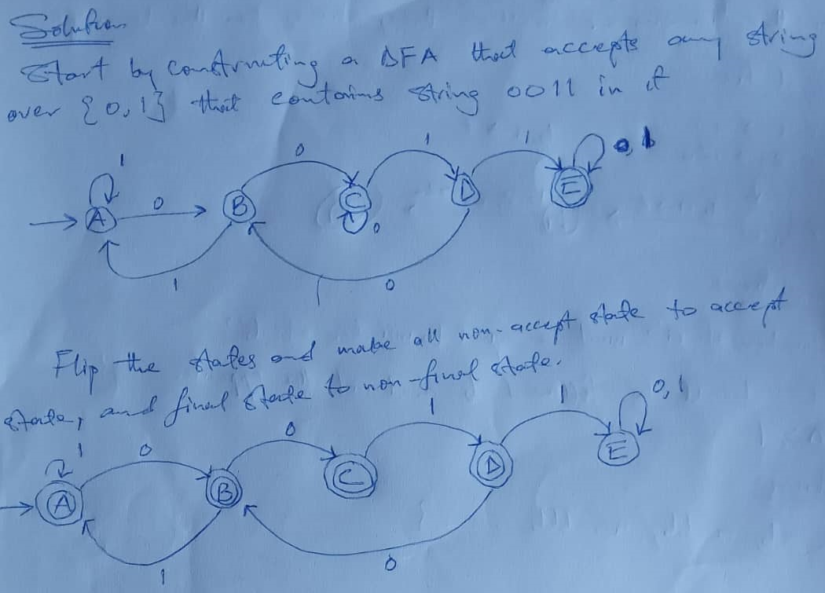

- Discuss Push Down Automata (PDA), its components and its tuples in details with a well labelled diagram. (10mks)

Ans.
Push down Automata has 3 components
- An input tape (0.5mk)
- A finite control unit (0.5mk)
- A stack with infinite size (0.5mk)
Finite Control Unit
Accept or Reject

Push or Pop

Input Tape
Stack (5mks)

A PDA is formally defined by 7 tuples as shown below:
Q = A finite set of states
∑ = Finite set of input alphabets
qo = the initial or start state, qo is in Q
F = A set of final / accepting state, which is a subset of Q.
∂ = A transition function.
Zo = Start stack symbol
r = A finite set of stack alphabets (3.5mks)

Question 3
- Convert the following epsilon ε NFA to its equivalent NFA. (10mks)

q₃
0
0
q₂
q₄
1
0
q₀
q₁
1
1
ε

Find E - closure of each state (2mks).
(ii) Draw E - closure transition for all 0’s and 1’s in transition table (3mks).
(iii) Draw the transition diagram of the NFA (3mks).
(iv) List and give reason for your accept states (2mks).

Ans.
- Given: ∑= {a, b}, L= {xϵ∑*|x is a string combination}, write all strings in ∑. (4mks)

Ans
{aaaa, abab, ε, abaa, aabb}

- Write the strings that the following DFA will accept. (3mks)
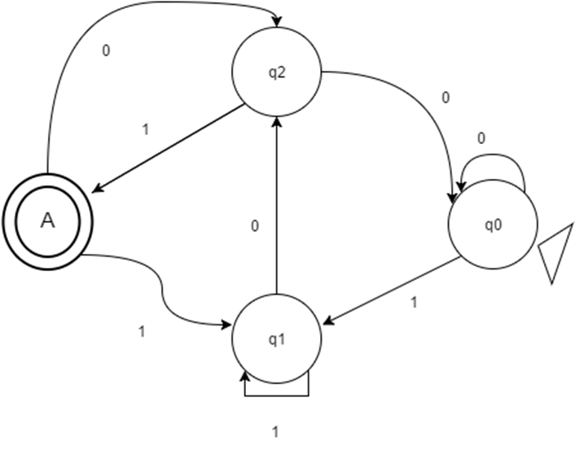
Ans.
X is a string such that it ends with ‘101’

- What does the following figure most correctly represent? (3mks)
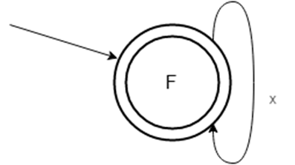
Ans.
Initial state as well as final state with loop X

Question 4
- In a tabular form discuss the following terms: Power of an alphabet, Language, Strings, Alphabet and Sigma plus (∑+). (10mks)
Ans.

Power of an alphabet | Language | Strings | Alphabet (∑) | Sigma plus (∑⁺)
Let ∑ be an alphabet.  ∑^{k} = the set of all the strings of length k  ∑* = ∑⁰ U ∑¹ U ∑² U…..  ∑⁺ = ∑¹ U ∑² U ∑³ U…. | A language is a collection of sentences of finite length all constructed from a finite alphabet of symbols. | A string or word is a finite sequence of symbols chosen from ∑  Empty string is ε ( or “epsilon”)  Length of a string W, denoted by /W/, is equal to the number of non- ε character in the string.  Eg. X = 0101100  X = 10 ε0011 ε101 | Alphabet is a finite, non-empty set of symbols.  It is denoted by ∑.  Example of an alphabet :  Binary : ∑ = {0, 1}  All lower case letters: ∑ = {a,b,c,d,…z}  Alphanumeric: ∑ = {a, b, c, A-Z, 0 -9 } | ∑⁺ = ∑* - ∑º
(10mks)

- Construct a DFA that accepts 01 or a string of at least one “1” followed by 0 over ∑ = (0,1) show an instance of trap state in your transition diagram. (5mks)

Ans.
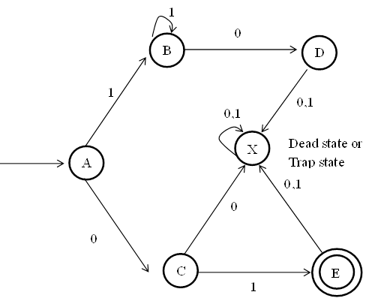
- Construct a PDA that accepts the language L = {0^{n}1^{n+m} 0^{n} / m, n>1} where ∑ = {0, 1} (5mks)
Ans.
0^{n}1^{n+m}0^{n} = 0^{n}1^{n}1^{m}0^{n}
L = {0110, 00111100, 00011111000…}

a, a/aa
a, z_{o}/az_{o} b, a/ ε b, b/bb a, b/ ε
q_{o}
q₁
q₂
q3
b, a/ ε b, z_{o}/bz_{o} a, b/ ε c, z_{o}/z_{o} q₄

